**BIOFEEDBACK AND HAND-WARMING**

Written by Psychologist and Biofeedback specialist Chris Gilbert, PhD | Adapted by Selena Chan, DO

**Hand-warming (from within) is a prime skill for self-regulation because it is associated with relaxation at every level.** With no change in room temperature or internal body temperature, skin temperature may vary as much as 25 degrees -- from 70° F to 95° F -- based solely on changes in perceived security.

**Skin Temperature**

Relaxed - 95°F

* 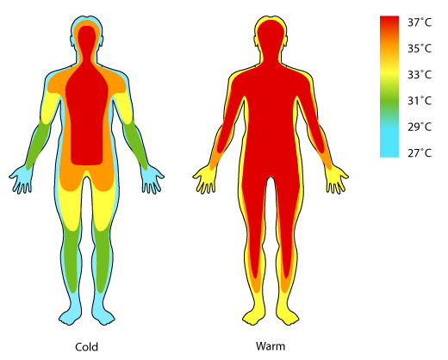Skin temperature varies in different places on the body, higher around the torso and head, lowest in the fingers and toes.
* Body temperature (under the tongue or armpit) tends to be stable, but temperature on the fingers can vary as much as 25 degrees depending on whether you’re chilled, and also whether you’re under stress.

Tense - 70°F

* **Hand temperature** under ideal conditions (stress-free, warm environment) is **between 90**° **F and 95**° **F**, always lower than under-the-tongue temperature.

**The Autonomic Nervous System shifts body resources and blood flow to reflect mind-body state:**

|  |  |  |
| --- | --- | --- |
| **Mind-Body State** | **Preparation for threat** | **Safety and maintenance** |
| **Peripheral blood vessels…**  (e.g., in hands) | https://smart.servier.com/wp-content/uploads/2016/10/vasoconstriction.png**Constricts**  Blood is pushed from skin and intestines 🡺 toward torso/head 🡺 Fuels deep muscles, heart, lungs, and brain | https://smart.servier.com/wp-content/uploads/2016/10/vasodilatation.png**Dilates**  Blood flow to skin and intestines  *Also increases skin temperature |
| Goals | Ensures maximum fuel available for emergency action (fight or flight response) | Inner repair and maintenance of health |
| Hand temperature | Image result for temperature map body  **Cooler hands** | Image result for temperature map body  **Warmer hands** |

In general, the body follows the conscious mind because that’s where decisions about danger will occur. This “danger” may be physical, social, or psychological, and can be very subtle…

|  |  |  |
| --- | --- | --- |
| Emotions such as… | **Failure, embarrassment, anxiety, impatience, or frustration** | **Contentment, peacefulness,**  **and a sense of safety** |
| Blood vessels… | Image result for temperature map body  **Constrict 🡺 Cooler hands**  *\*more in some people than others* | Image result for temperature map body  **Dilate 🡺 Warmer hands** |

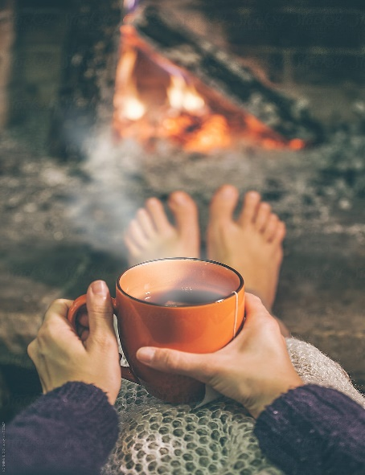**Signs of Hand Warming**

These are the main sensations of increased peripheral blood flow:

* Warmth, moving downward from the wrists and palm toward the fingers
* Pulsations -- feeling your heartbeat in your hands
* Heaviness
* Fullness or expansion
* Slight tingling or prickling

You may feel all of these or just one or two. The thermometer shows smaller changes than you can feel, but your discrimination will get better with practice. Touching your fingers to your lower lip will give you some idea of your hand temperature. Above 90° F your fingers should feel warmer than your lips.

**BIOFEEDBACK PRACTICE**

There is no one best way to learn hand-warming, so experiment and be flexible while using biofeedback. Trying too hard or pressuring yourself to perform will backfire and make the hands cooler**.** The biofeedback gives you a continuous signal of what you’re doing but attending too much to the feedback will pull your attention from the method you’re using.

**Start by trying any of these methods with full attention, for several minutes:**

* Dwelling on a memory of warmth and relaxation, such as a hot bath or lying on the beach
* Imagining an increase in skin blood flow any way you can
* Repeating these words while imagining the result: “*My hands are warm and heavy*.”
* Imagining and recalling the specific sensations of hand warmth (see above)
* Breathing fully and slowly with a mental focus on something relaxing

When you succeed in hand-warming, notice in detail how it feels so that you can remember it next time and repeat it. Maintaining the necessary mental focus and avoiding distractions takes self-discipline and repetition; it’s never as easy as flicking a switch. Control does, however, improve with practice. What you’re learning gives you the power to cut short or reverse many effects of emotional stress.

*“Peace of mind” means “peace of body” also.*

**Biofeedback Practice with Stress Thermometers and the Derma-Therm Sensor**

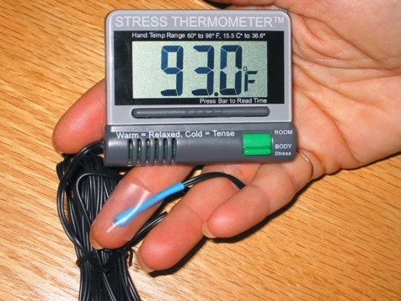These devices can be used as biofeedback sensors, giving you a clue as to how your body is responding to stressful emotions of any sort.

By doing a relaxation exercise (meditation, slow breathing, imagery, muscle relaxation) you can influence your autonomic nervous system to increase blood flow to the skin, especially the fingers and toes. This is associated with feelings of safety and security.

If you’re in a cool environment, the body conserves heat by constricting blood vessels in the skin, so hand temperature may drop because of that rather than from stress. **But if you’re in a comfortably warm environment and your fingers are still cold, it may be an indicator of stress.** Other possible reasons for cold hands include low thyroid level, anemia, and sleepiness.

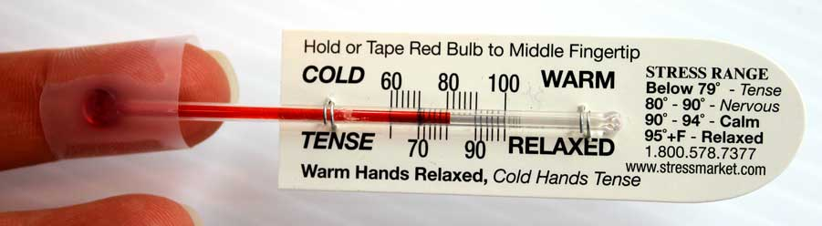For migraine sufferers, the device can be worn routinely and used as an early-warning indicator of a migraine starting to build. Taking time out to relax and change the circulation can interrupt or slow the progress toward migraine, and sometimes prevent it altogether.

**DIRECTIONS FOR DERMA-THERM SKIN TEMPERATURE SENSOR**

**How to use the Derma-Therm:**

* The temperature is indicated by small vertical lines of color (like a tiny rainbow).
* Placing the sensor
  + The white backing peels off when you’re ready to tape the sensor to the skin.
  + This device is to be taped to the skin in order to display skin temperature directly under the black sensor.
  + Taping the sensor on the back of the hand is easiest, but that will be warmer than the fingers
  + Taping the sensor along a finger, inner or outer surface, will show more variability in temperature
* Tips
  + The sensor can be used for a long time, but the tan tape will lose its stickiness. When that happens, you can easily remove the tan tape and then tape the sensor to the skin with any transparent tape, single or double-sided.
  + You can test its response by breathing on it or holding it between your palms to increase the temperature temporarily.